High Capacity Performance Boost

[Watch Video](https://www.kingston.com/en/video/play?videoId=hVTannGsuCJ2nH5rLadyq3Sev7UVM9qv_v_cWsd5_fPxyoiDUoP8_B3BlGhxpUnAGMEXilVpULJGtuXMTgHI1Q2&start=0&autoPlay=False&chromeless=False&captionOption=No)

SNV3S

* [Intro](https://www.kingston.com/en/ssd/nv3-nvme-pcie-ssd#product-features)
* [Key Features](https://www.kingston.com/en/ssd/nv3-nvme-pcie-ssd#key-feature)
* [Specifications](https://www.kingston.com/en/ssd/nv3-nvme-pcie-ssd#specifications)
* [Resources](https://www.kingston.com/en/ssd/nv3-nvme-pcie-ssd#links)
* [Datasheet](https://www.kingston.com/datasheets/snv3s_us.pdf)

[**Buy**](https://www.kingston.com/en/ssd/nv3-nvme-pcie-ssd#atc)

NV3 PCIe 4.0 NVMe SSDFor high speed, low power storage needs

Kingston’s NV3 PCIe 4.0 NVMe SSD is a next-gen storage solution powered by a Gen 4x4 NVMe controller, delivering read/write speeds up to 6,000/5,000MB/s1. It offers lower power consumption and reduced heat, optimizing your system's performance without compromising value. The compact, single-sided M.2 2280 (22x80mm) design expands storage up to 4TB2 conserving space for other components. Experience NVMe speeds with NV3.

Available in capacities from 500GB – 4TB2 to give you all the space you need for applications, documents, photos, videos, games and more.

* Gen 4x4 NVMe PCIe performance
* Ideal for high speed, low power storage
* Capacities up to 4TB2

Key Features



Gen 4x4 NVMe PCIe performance

Upgrade your system with read/write speeds up to 6,000/5,000MB/s1.



Ideal for systems with limited space

Easily integrate into designs with M.2 connectors. Perfect for thin laptops and small form factor PCs.



Increased storage space

Available in a variety of high capacities up to 4TB2 providing ample space to store files, videos, documents, and games with room to spare.

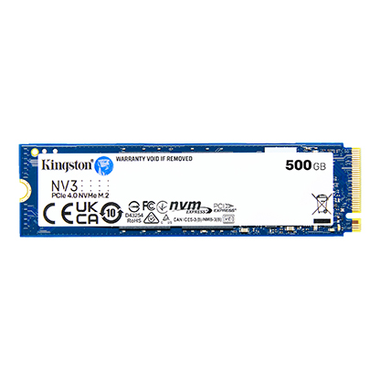

* [NV3 PCIe 4.0 NVMe SSD 500GB](javascript:void(0))
* [NV3 PCIe 4.0 NVMe SSD 500GB](javascript:void(0))
* [NV3 PCIe 4.0 NVMe SSD 500GB](javascript:void(0))

Capacity

 500GB

 1TB

 2TB

 4TB

* Part Number: SNV3S/500G
* Gen 4x4 NVMe PCIe Performance
* 3-year limited warranty
* Includes [Acronis cloning software](https://www.kingston.com/cloning)
* Up to 5,000MB/s Read, 3,000MB/s Write

[**Where to Buy**](https://www.kingston.com/en/wheretobuy)

Specifications

|  |  |
| --- | --- |
| Form Factor | M.2 2280 |
| Interface | PCIe 4.0 x4 NVMe |
| Capacities2 | 500GB, 1TB, 2TB, 4TB |
| Sequential Read/Write1 | 500GB – 5,000/3,000MB/s 1TB – 6,000/4,000MB/s 2TB - 4TB – 6,000/5,000MB/s |
| NAND | 3D |
| Endurance (Total Bytes Written)3 | 500GB – 160TB 1TB – 320TB 2TB – 640TB 4TB – 1280TB |
| Storage Temperature | -40°C~85°C |
| Operating Temperature | 0°C~70°C |
| Dimensions | 22mm x 80mm x 2.3mm |
| Weight | 7g (All capacities) |
| Vibration Non-operating | 20G (10-1000Hz) |
| MTBF | 2,000,000 hours |
| Warranty/Support4 | Limited 3-year warranty with free technical support |